Picture/Graphic

(Optional)

Final Project Report

Project Title

ME 755/756

May 2017

Group Member 1 (Project Manager)

Group Member 2

Group Member 3

List all project team members

Faculty Advisor:

Industry Advisor/Sponsor:

**Disclaimer**

This document is provided as part of the requirements of Mechanical Engineering course ME 755 & 756, at the University of New Hampshire. It does not constitute a professional engineering design document. Although the information is intended to be accurate, students, instructors, and the University of New Hampshire make no claims, promises, or guarantees about the accuracy, completeness, or adequacy of the information. The user of this document shall ensure that its use does not violate New Hampshire law with regard to professional licensing and certification requirements, including any work resulting from this student-prepared document required to be under the responsible charge of a licensed engineer.

**Table of Contents**

List of Figures iv

List of Tables iv

Introduction 1

Scope of Work #

Schedule #

Analysis/Calculations…………………………………………………………………………...#

Summary #

References #

Layout and detail drawings…………………………………………………………………… #

Appendix 1 #

**List of Figures** (if utilized)

Figure 1: Caption for figure #

Figure 2: Caption for figure #

**List of Tables** (if utilized)

Table 1: Caption for table #

Table 2: Caption for table #

**Guidelines for your Project report**

* Cover page shall consist of the project title, submission name, submission date, all team members with the project manager listed, faculty advisor and industry advisor/sponsor and company.
* All projects shall have the disclaimer placed on page ii of the document.
* All titles for sections, table of contents, list of figures/tables, etc. shall be bolded and 2 points larger than the text of the main document.
* All text within the body of the document shall be12 point Times New Roman.
* Margins shall be 1 inch on all sides.
* Line spacing shall be double spacing.
* There shall be an extra return added between the end of one section and the title of the next section.
* No extra spacing between paragraphs is required.
* Entries within the list of figures/tables shall be in the same font as the main document.
* Every figure shall have a caption whose placement will be centered underneath the figure.
* Every table shall have a caption whose placement will be centered above the table.
* All captions should be descriptive of the figure or table. Captions must have a font size of 10 point; captions shall be single spaced.
* A caption is need for graphics/pictures if the intent of subject is not readily evident. Picture/graphics do not need to be listed in the Table of Contents.
* Any symbols used in the text should be italicized and use proper subscripts if appropriate (i.e. Hmax should be *Hmax*).
* First person narrative is not appropriate.
* References shall conform to the APA author-date citation style. A quick guide to this format is given here: <https://www.wsulibs.wsu.edu/quickguides/apa>
* References shall be located in a separate section, which will be placed before any and all appendices.
* Any attached hand calculations should be neat and orderly. The scans of these calculations should be completely legible.

**Introduction**

* Graphics and/or images should be utilized to enhance the reader’s understanding of the project.
* Provide enough information on the project to give the reader a thorough understanding of the background, goals, and objectives of the project.
* Describe “why” the project is being undertaken.

**Scope of Work**

* Describe the process that will be utilized in the development of the project.
* Describe the deliverables of the project.
* Describe tasks completed and your findings/results.
* Describe tasks that remain.
* Include a brief discussion and the results of any alternative analysis that have been completed.

**Schedule**

* Include a graphic depiction of the schedule that is readable and includes major tasks and timeframes. The schedule provided should be from September to May.
* Describe the project schedule and the tasks that are on the critical path for completion.
* Explain how the various project tasks were distributed among project team members.

**Analysis/Calculations**

* Discuss in detail the analyses the were performed and why
* Include calculations
* Describe how your analyses provided direction and insight to complete the project

**Summary**

* Provide a summary of the project activities to date.
* Provide a description of the tasks left to be completed.
* Include a discussion of obstacles encountered and how they were resolved.
* Include a discussion of other potential obstacles.
* What will be the team’s first order of business at the start of the spring semester?

**References**

* Include ALL documents, reports, design guidelines that were utilized in the development of this report.

**Layout and detailed drawings**

* Include a general layout drawing (if applicable)
* Include detailed drawing of the various components in the final design
* Make sure that all included drawings are of sufficient size to be readable

**Sample**

This is a sample of the way the various sections within your document should be presented. Please note that, as described in the above section, this format must be utilized. It is not uncommon for an engineering company to adopt very strict standards in the development of documents. This helps to provide a uniform and recognizable “brand” for a company. Additionally, many agencies have standard templates that must be utilized in the development of submissions to the agency. This standardization allows the reviewer/grader to focus on the content of the document as opposed the “look” of the document.

|  |  |  |  |
| --- | --- | --- | --- |
| **Table 1: Summary of Bridge Condition by Number of Bridges** | | | |
| **Bridge Condition** | **State-Owned Bridges** | **Non State-Owned Bridges** | **Totals** |
| Red List (Structurally Deficient/Poor) | 154(7.1%) | 338(20.0%) | 492(12.8%) |
| Yellow List (Fair) or Green List (Good) | 2,006 | 1,350 | 3,356 |
| **Totals** | **2,160** | **1,688** | **3,848** |

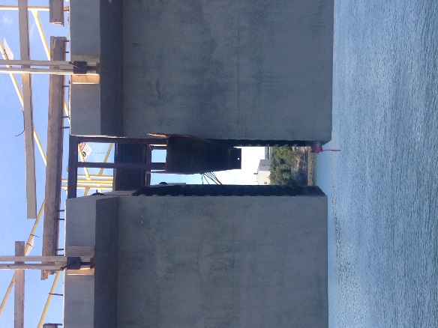

Pre-cast segmental sections of the Saragh Mildred Long Bridge prior to closure poor.